ROAD ACCIDENT IN INDIA ANALYSIS PROJECT

1. Project Overview
This project focuses on analyzing road accident data using PostgreSQL to identify key accident trends, driver behavior patterns, weather impacts, and severity distribution. The objective is to uncover data-driven insights that can assist in improving road safety and policy planning.

2. Dataset Summary
- Dataset Name: Road_accident_data.csv
- Total Records: 12,316
- Total Columns: 32
- Tools Used: PostgreSQL, SQL
- Key Columns: time, day_of_week, type_of_vehicle, cause_of_accident, weather_conditions, road_surface_type, accident_severity, number_of_casualties, number_of_vehicles_involved

KPI 1 — Total Accidents, Vehicles & Casualties
SQL Query:
SELECT COUNT(*) AS total_accidents,
SUM(number_of_vehicles_involved) AS total_vehicles,
SUM(number_of_casualties) AS total_casualties
FROM road_accidents;
Explanation:
Calculates the total accidents, vehicles involved, and casualties.
📌 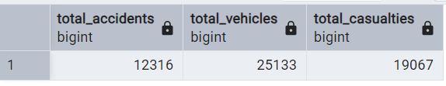

KPI 2 — Unique Categories Check
SQL Query:
SELECT COUNT(DISTINCT cause_of_accident) AS unique_causes,
COUNT(DISTINCT type_of_vehicle) AS unique_vehicle_types,
COUNT(DISTINCT weather_conditions) AS unique_weather_conditions
FROM road_accidents;
Explanation:
Finds unique causes, vehicle types, and weather conditions.
📌 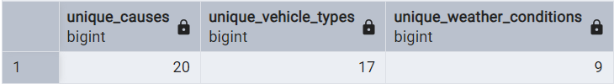

KPI 3 — Accidents by Day of the Week
SQL Query:
SELECT day_of_week, COUNT(*) AS total_accidents
FROM road_accidents
GROUP BY day_of_week
ORDER BY total_accidents DESC;
Explanation:
Shows which days of the week have the highest number of accidents.
📌 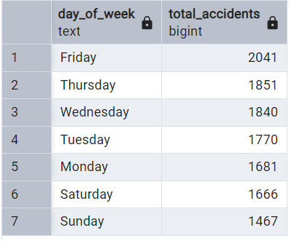

KPI 4 — Accidents by Time of Day
SQL Query:
SELECT CASE
WHEN EXTRACT(HOUR FROM time) BETWEEN 5 AND 11 THEN 'Morning'
WHEN EXTRACT(HOUR FROM time) BETWEEN 12 AND 16 THEN 'Afternoon'
WHEN EXTRACT(HOUR FROM time) BETWEEN 17 AND 20 THEN 'Evening'
ELSE 'Night' END AS time_of_day,
COUNT(*) AS total_accidents
FROM road_accidents
GROUP BY time_of_day
ORDER BY total_accidents DESC;
Explanation:
Groups accidents based on time intervals to find peak hours.

📌 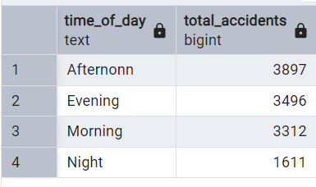
KPI 5 — Accidents by Driver Age Group
SQL Query:
SELECT
age_band_of_driver,
COUNT(*) AS total_accidents
FROM road_accidents
GROUP BY age_band_of_driver
ORDER BY total_accidents DESC;
Output

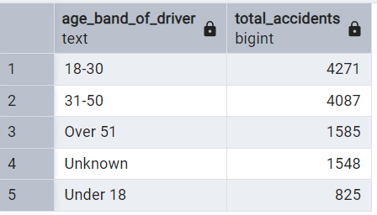

KPI 6 — Accidents by Type of Vehicle
SQL Query:
SELECT
type_of_vehicle,
COUNT(*) AS total_accidents
FROM road_accidents
GROUP BY type_of_vehicle
ORDER BY total_accidents DESC
LIMIT 10;
Output

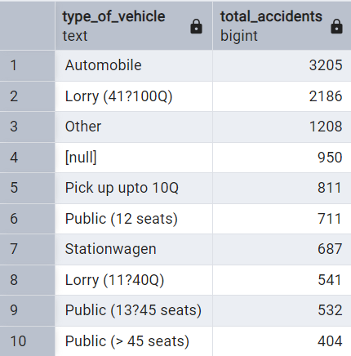

KPI 7 — Accidents by Weather Conditions
SQL Query:
SELECT
weather_conditions,
COUNT(*) AS total_accidents
FROM road_accidents
GROUP BY weather_conditions
ORDER BY total_accidents DESC;
Output
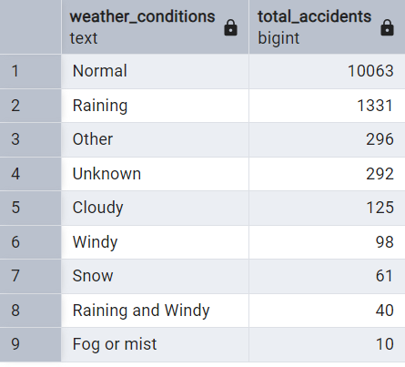

KPI 8 — Accidents by Road Surface Type
SQL Query:
SELECT
road_surface_type,
COUNT(*) AS total_accidents
FROM road_accidents
GROUP BY road_surface_type
ORDER BY total_accidents DESC;
Output
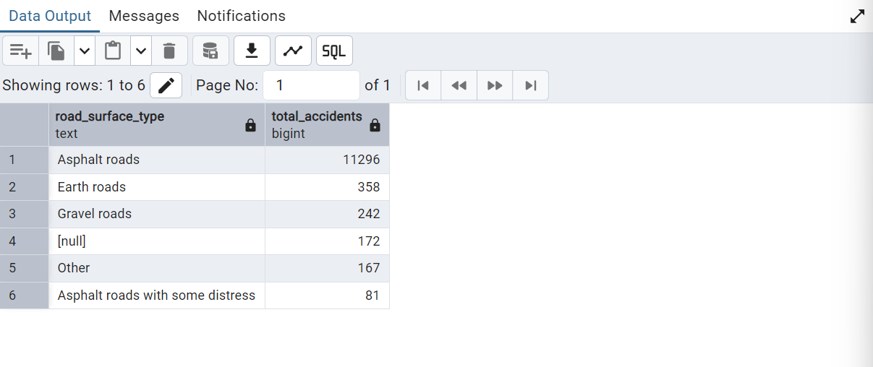

KPI 9 — Count Accidents by Severity
SQL Query:
SELECT
accident_severity,
COUNT(*) AS total_accidents
FROM road_accidents
GROUP BY accident_severity
ORDER BY total_accidents DESC;
Output

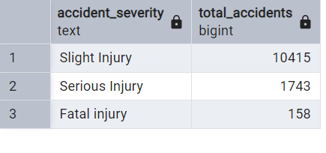

KPI 10 — Average Casualities by Severity
SQL Query:
SELECT
accident_severity,
ROUND(AVG(number_of_casualties),2) AS avg_casualties
FROM road_accidents
GROUP BY accident_severity
ORDER BY avg_casualties DESC;
Output

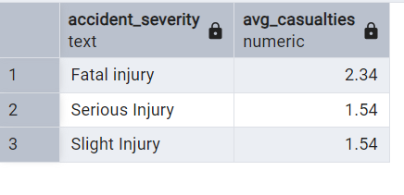

KPI 11 — Top Causes of Accidents
SQL Query:
SELECT
cause_of_accident,
COUNT(*) AS total_accidents
FROM road_accidents
GROUP BY cause_of_accident
ORDER BY total_accidents DESC
LIMIT 10;
Output

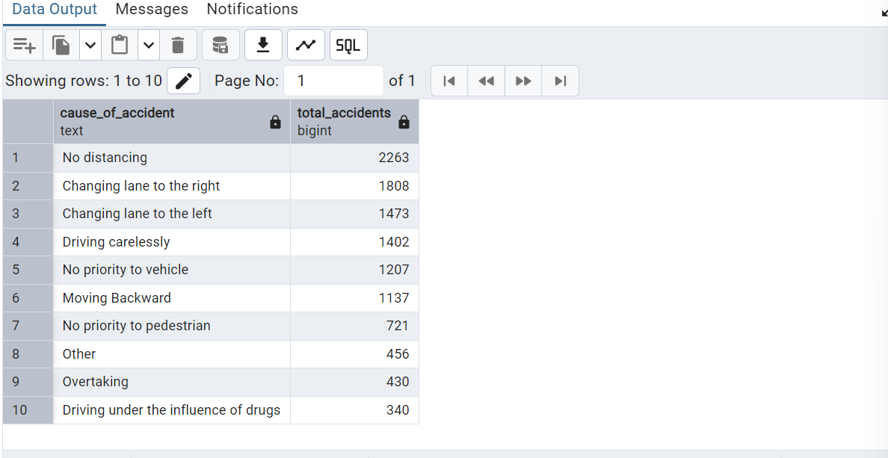

KPI 12 — Accidents by Casualty Severity
SQL Query:
SELECT
casualty_severity,
COUNT(*) AS total_casualties
FROM road_accidents
WHERE casualty_severity IS NOT NULL
GROUP BY casualty_severity
ORDER BY total_casualties DESC;
Output

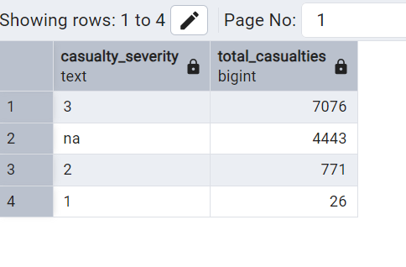

KPI 13 — Gender-wise Casualties
SQL Query:
SELECT
sex_of_casualty,
COUNT(*) AS total_casualties
FROM road_accidents
GROUP BY sex_of_casualty
ORDER BY total_casualties DESC;
Output
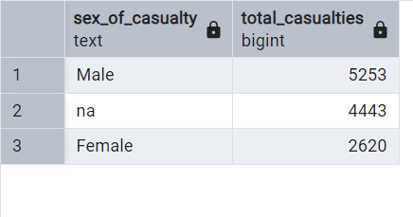

KPI 14 — FINAL SUMMARY :
SQL Query:
CREATE VIEW accident_summary AS
SELECT
day_of_week,
weather_conditions,
road_surface_type,
accident_severity,
COUNT(*) AS total_accidents,
SUM(number_of_casualties) AS total_casualties
FROM road_accidents
GROUP BY day_of_week, weather_conditions, road_surface_type, accident_severity;

SELECT * FROM accident_summary;
Output
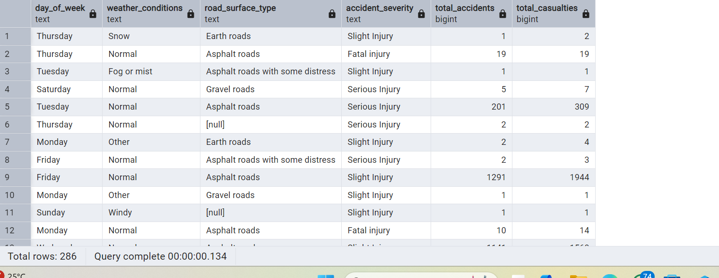

Credit :
Author :- Pritam Nagar
Github :- https://github.com/Pritam9952
Linkedin :- https://www.linkedin.com/in/pritam-nagar

